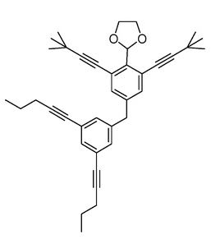**Isomers**

* Isomers are compounds that contain the same atoms but have different arrangements.
* Isomers will have the same molecular formula but different physical and chemical properties.
* Isomers can be classified as either structural or stereoisomers.

**Structural (constitutional) Isomers**

In structural isomerism, the atoms are arranged in a completely different order.

**There are three types of structural isomers:**

* **chain**
* **positional**
* **functional group (not mentioned in Pearson)**
* **Chain Isomers**

These isomers are due to branching in the carbon chains.

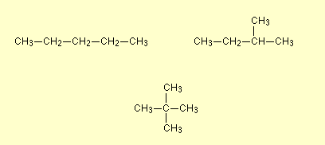

* **Positional Isomers**

The basic carbon skeleton remains unchanged in position isomerism, but essential groups are moved around on that skeleton.

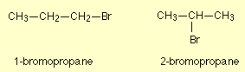

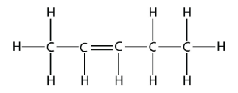

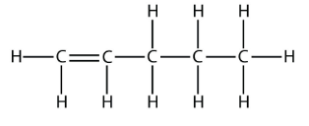



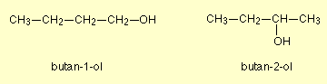

* **Functional Group Isomerism**

Like positional isomerism, changing the essential groups leads to new functional groups.

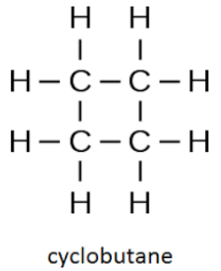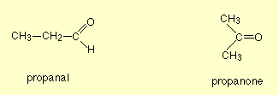

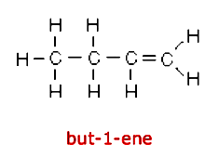

**Stereoisomerism**

Stereoisomers are molecules with the same molecular formula and sequence of bonded atoms but differ in the three-dimensional orientations of their atoms in space.

**Examples of stereoisomerism include**

* **geometric (cis-trans)**
* **optical (not covered in Pearson)**
* **Geometric (Cis-Trans) Isomerism**

Geometric isomers occur due to restricted rotation within a molecule.

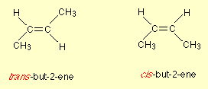

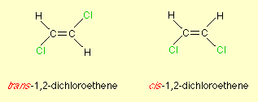

* **Optical isomers**

Optical isomers occur when two molecules are no-superimposable mirror images of each other. Letters are often added to the name to distinguish between the two.

